Write Up

Kai Li from MRSD

Q1.1

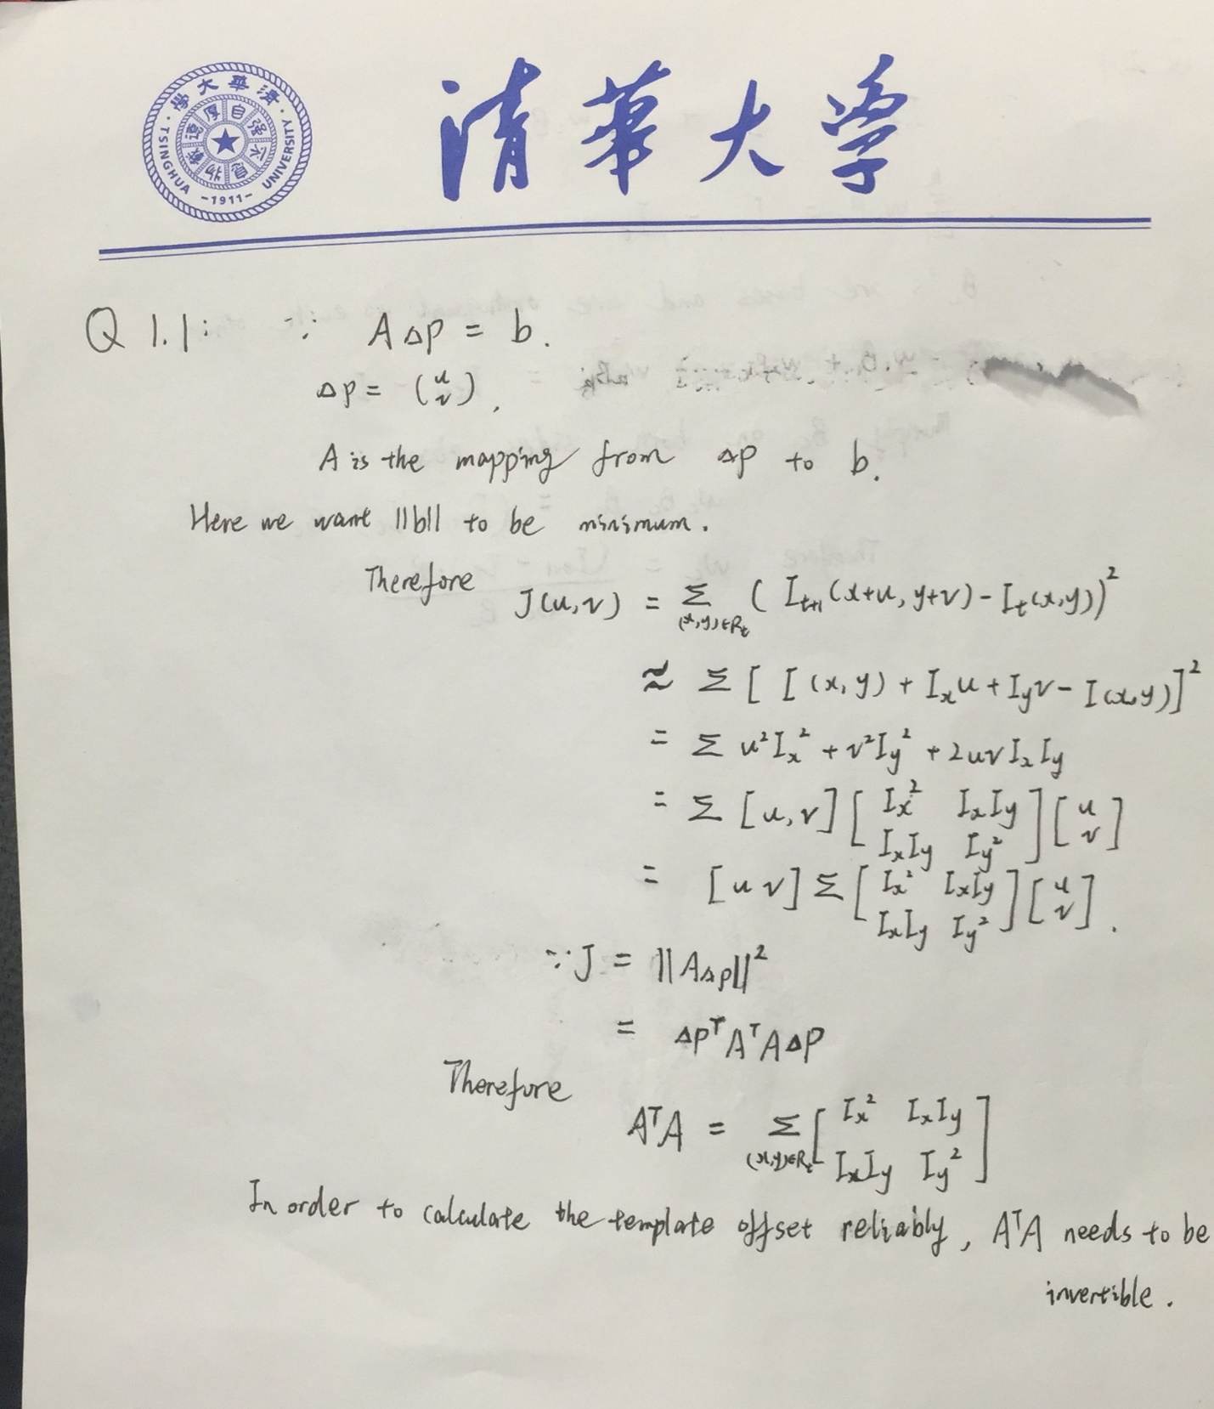

Q1.2

Please to refer to LucasKanadeInverseCompositional.m file for more details.

Q1.3

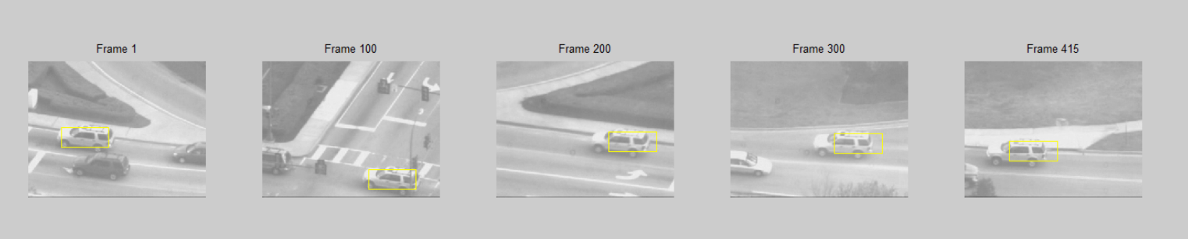

The above picture is the desired output at frame1, 100, 200 ,300 and 415. We can see with the number of frames increases, the tracking becomes less accuracy, and the rectangle seems to have drifted near the end of frames. The rects are already saved in carseqrects.mat. See more details in testCarSequence.m

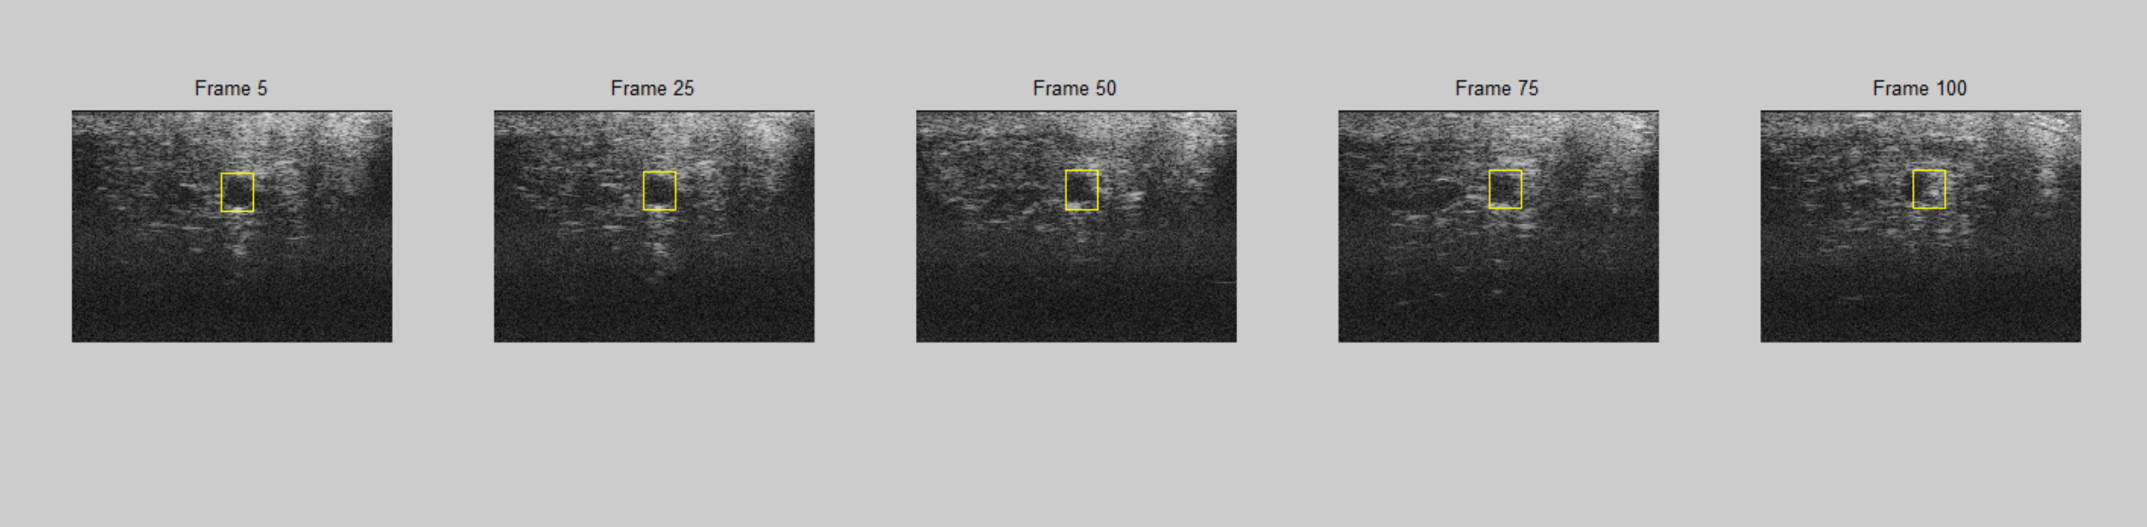

The above picture is the desired output of tracking a beating vessel, and see more details in testUltrasoundSequence.m

Q1.4 (Extra credits)

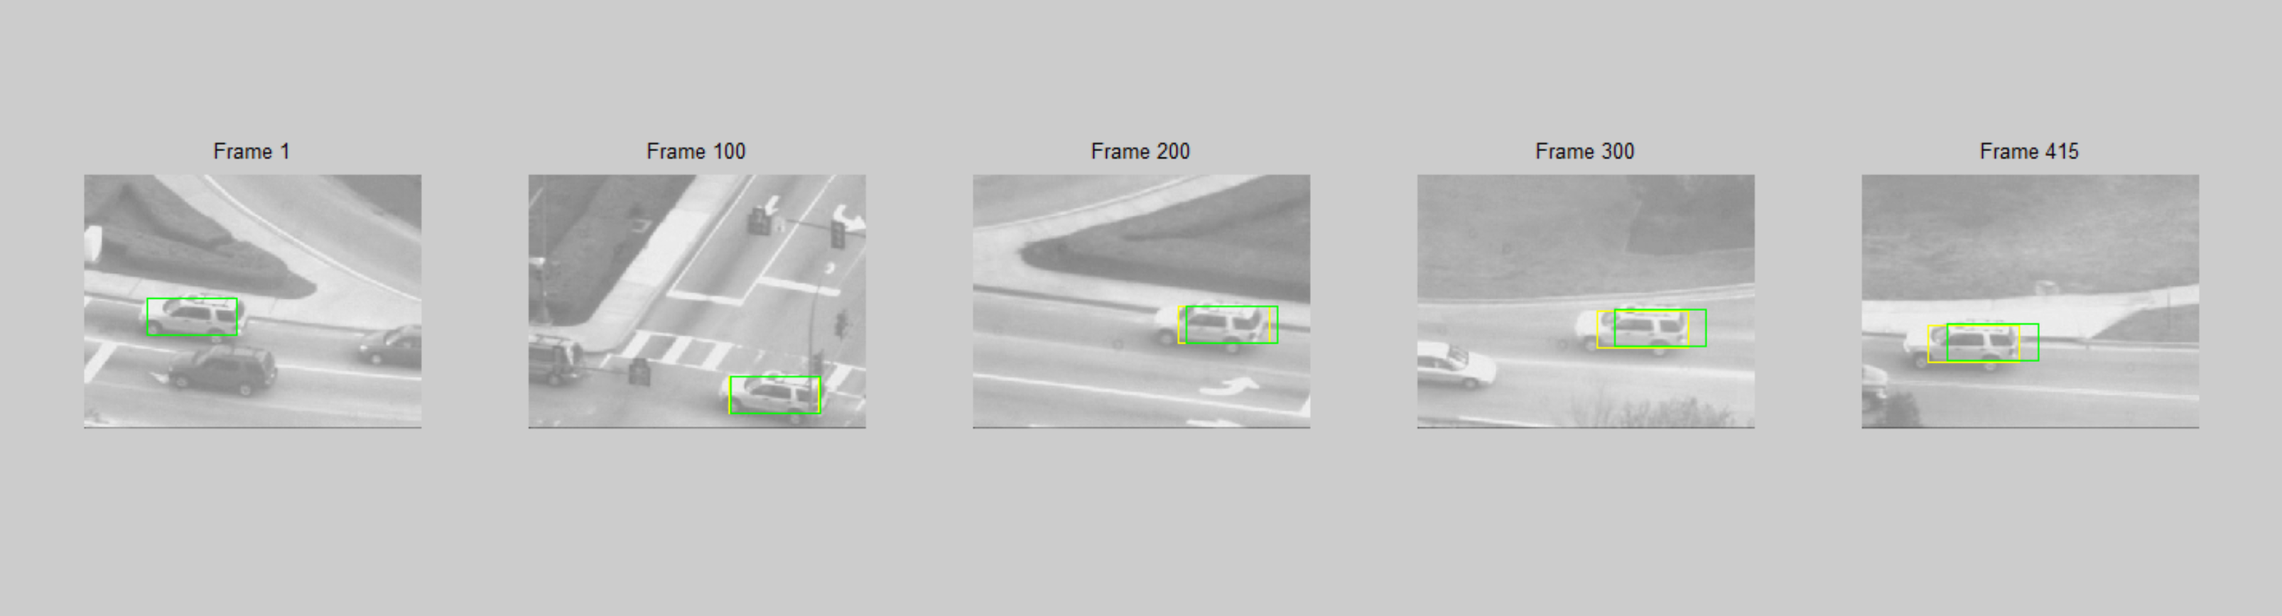

Lucas-Kanade tracking with template correction for the car sequence.

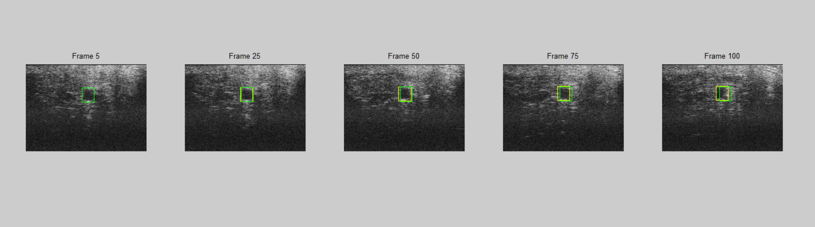

Lucas-Kanade tracking with template correction for the ultrasound sequence.

See the detailed codes in testCarSequenceWithTemplateCorrection.m and testUSSequenceWithTemplateCorrection.m.

We can see the yellow rectangles are the modified tracking and the green ones are the tracking without modification. The yellow ones are obviously more accurate than the green ones.

Q 2.1

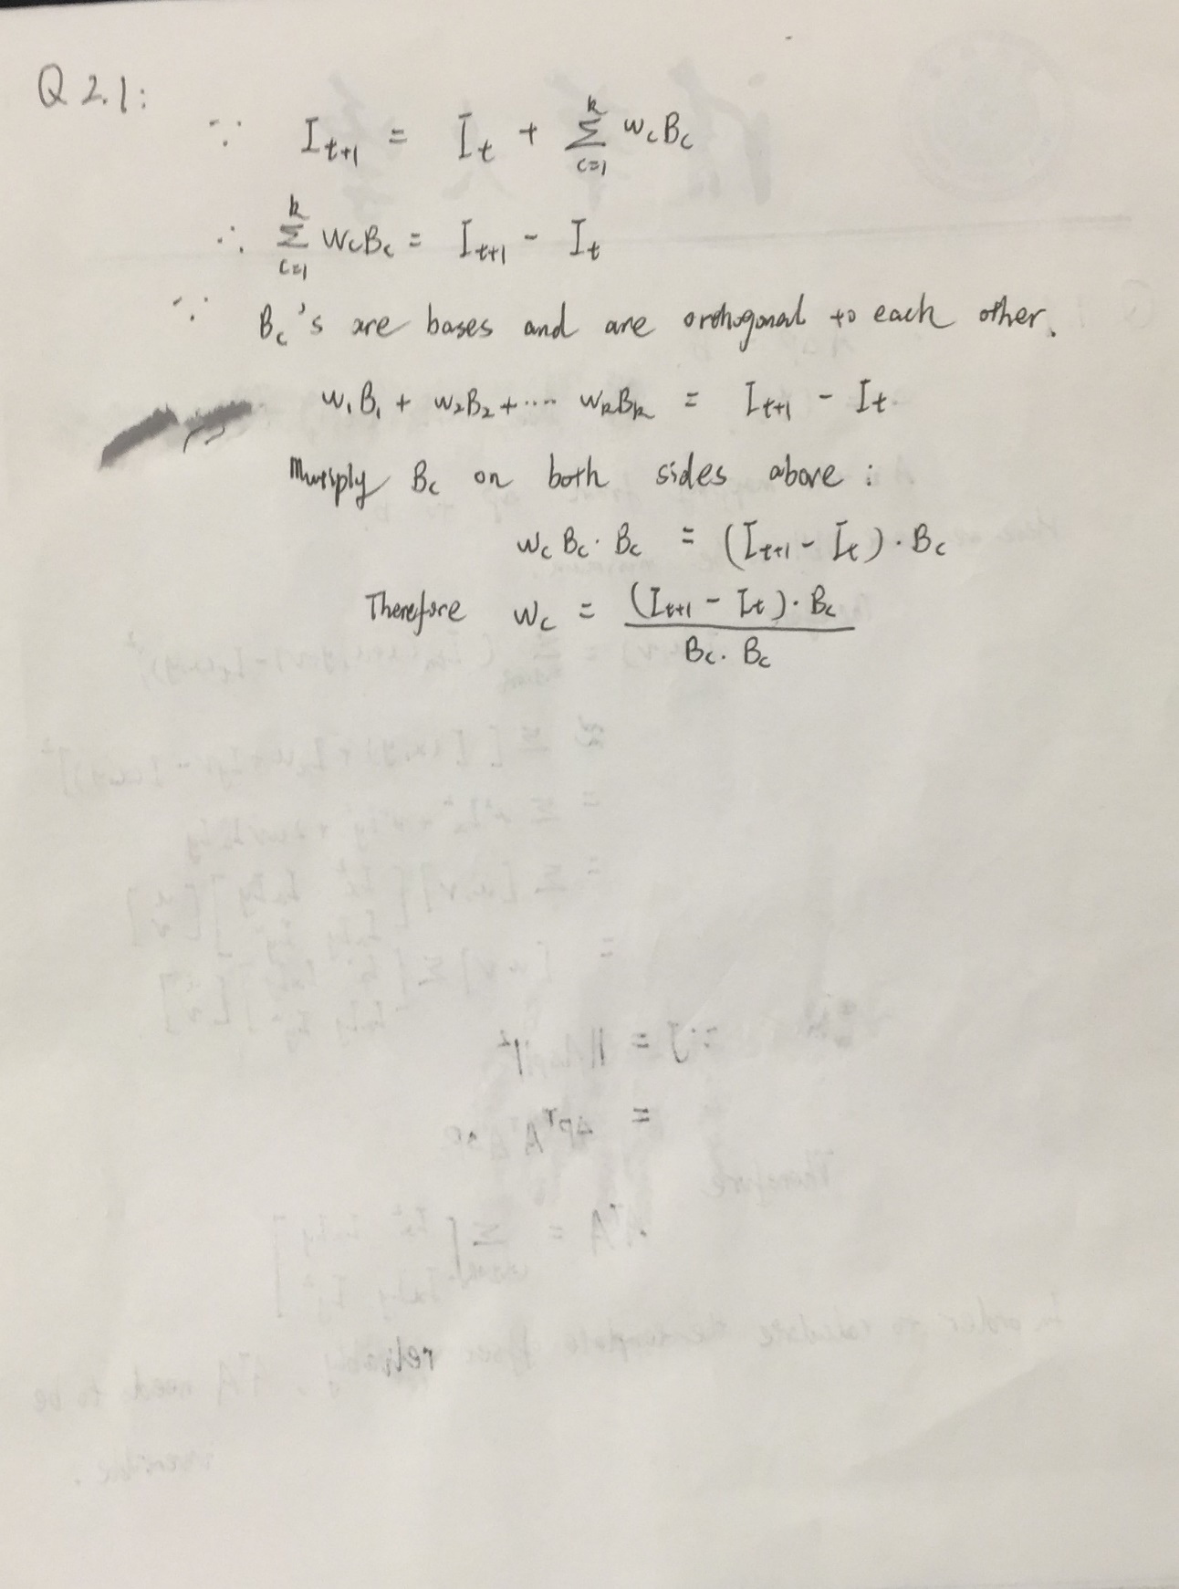

Q2.2

Please refer to LucasKanadeBasis.m for more details.

Q2.3

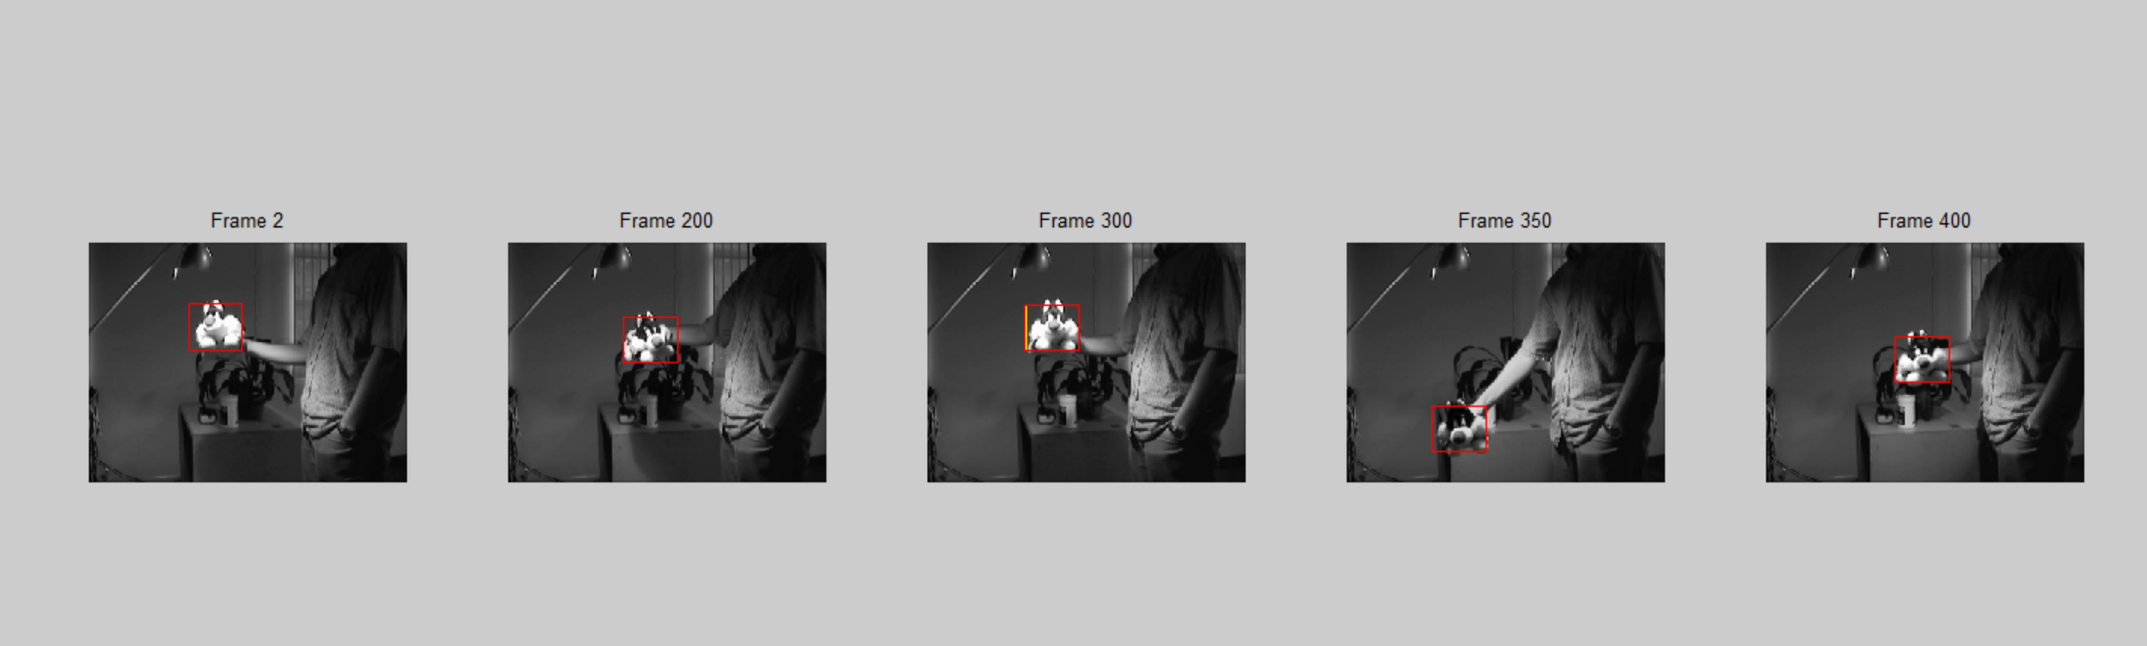

Lucas-Kanade Tracking with Appearance Basis

Please refer to testSylvSequence.m for more details.

Q3.1

Please refer to LucasKanadeAffine.m for more details.

Q3.2

Please refer to SubtractDominantMotion.m for more details.

Q3.3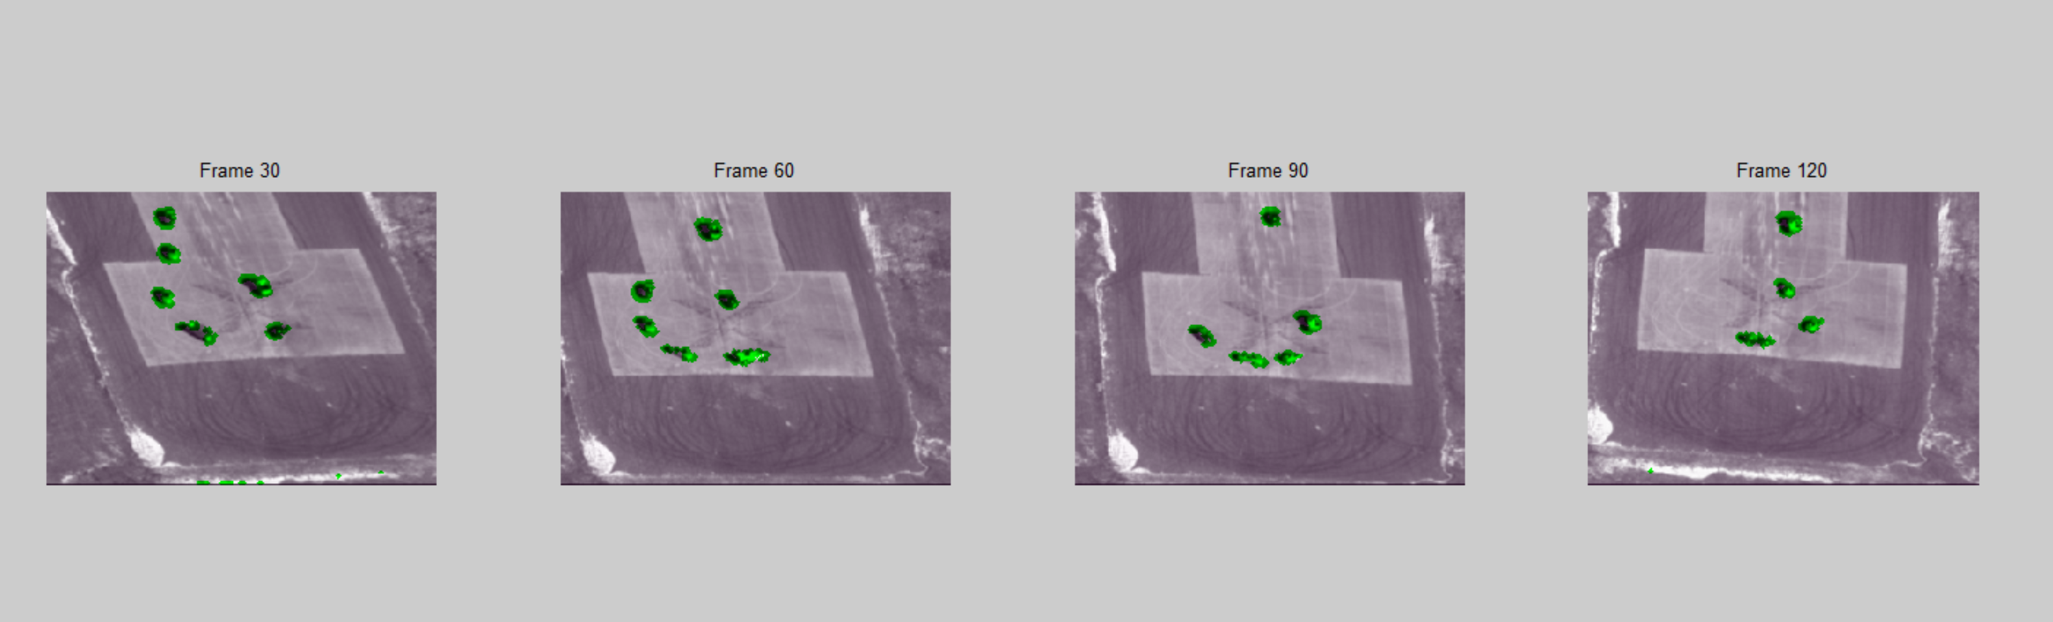

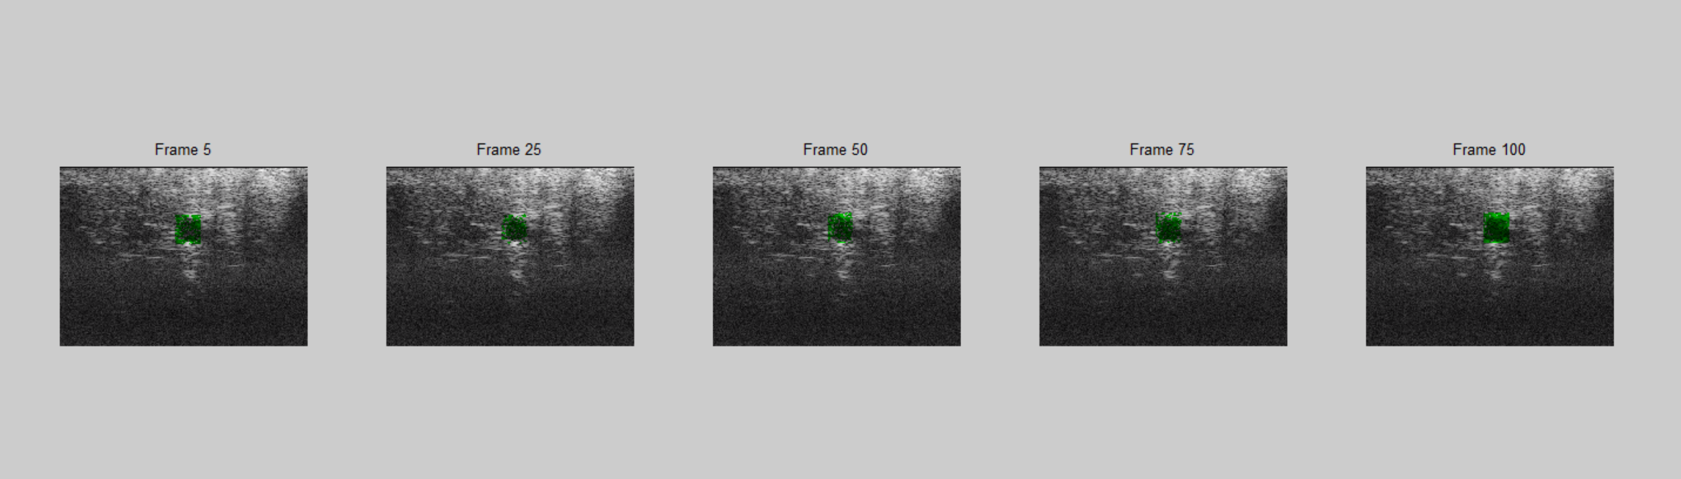

Please refer to testAerialSequence.m and testUSSeqAffine.m for more details.